


Committee on Committees Minutes

Associated Students
DATE: May 26, 2026
LOCATION: AS Main CoC Room Minutes/Actions recorded by: Vice Chair

CALL TO ORDER: 5:00PM by Lily, Internal Chair

QOTW: What summer fun are you looking forward to?

A. MEETING BUSINESS

- Roll Call

Name | Note:  absent (excused/not excused)  arrived late (time)  departed early (time)  proxy (full name) | Name | Note:  absent (excused/not excused)  arrived late (time)  departed early (time)  proxy (full name)
Lily Strange | Present | Savanah Lizet Aldaba | Present
Shuyi Sum | Present | Adam Orenstein | ...
Oliver Ramirez Carrera | Excused | Archish Prakhya | Present
Layla Hakim | Present
Mira Ikladious | Present

- Acceptance of Excused Absences

MOTION/SECOND: Mira/Lily
Motion Language: Motion to excuse Oliver from today’s meeting.
ACTION: Consent

- Acceptance of Proxies

B. PUBLIC FORUM

- EXTERNAL REPORTS

- Advisor’s Report

- Executive Officer’s Report(s)

- Group Project/Member Report(s)
  - Advisor and Senate Liaison Reports

Lily Strange - Internal Chair
    - QOTW: cathleen stone island! 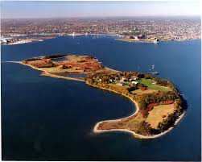
    - Checking in on passdown meetings
    - New logo! Let’s pick one for the tablecloth to get that ordered ASAP
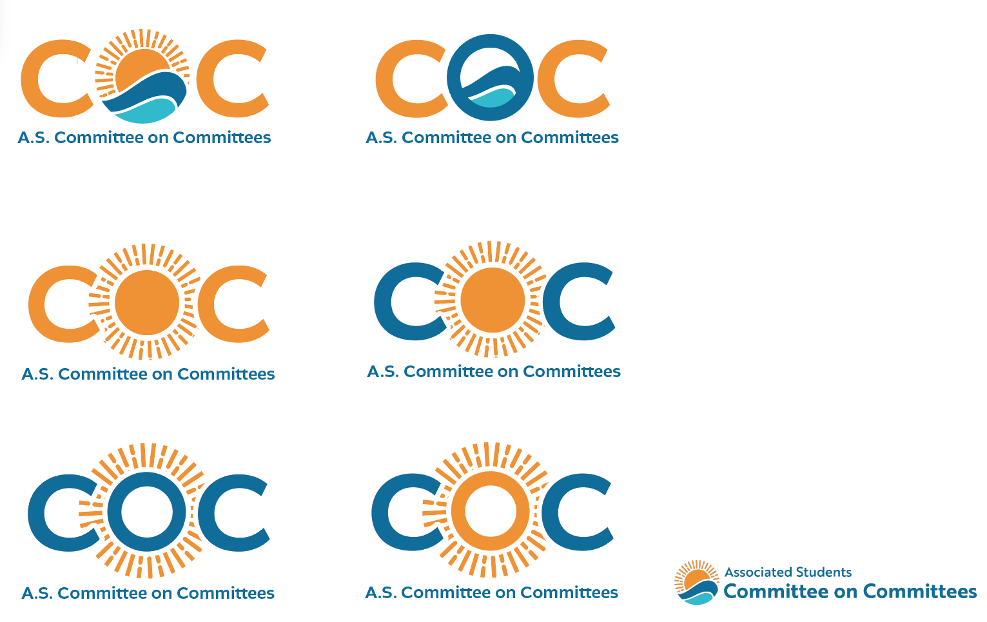
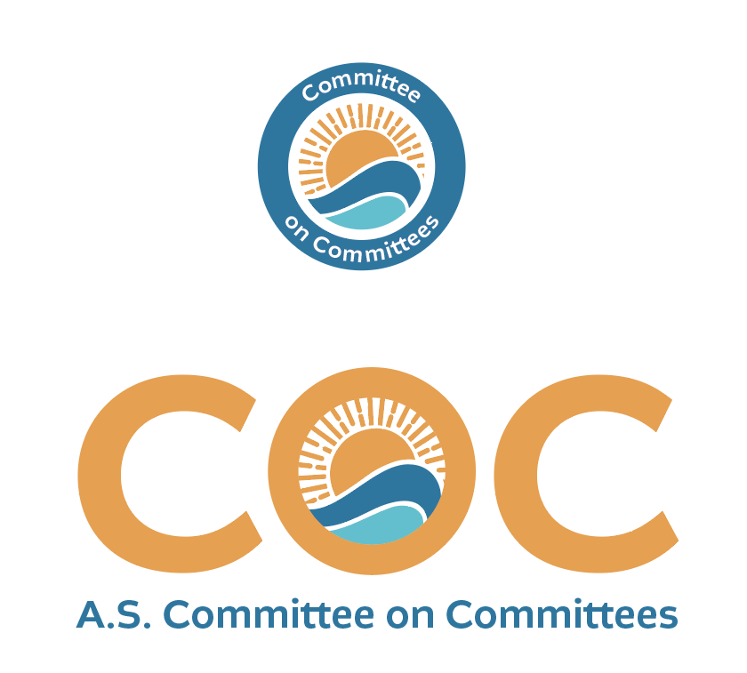
    - Checking in on publicity for CoC + office of the controller
    - Tabling next week!! Looks like Friday, June 5th 12pm-2pm??
      - 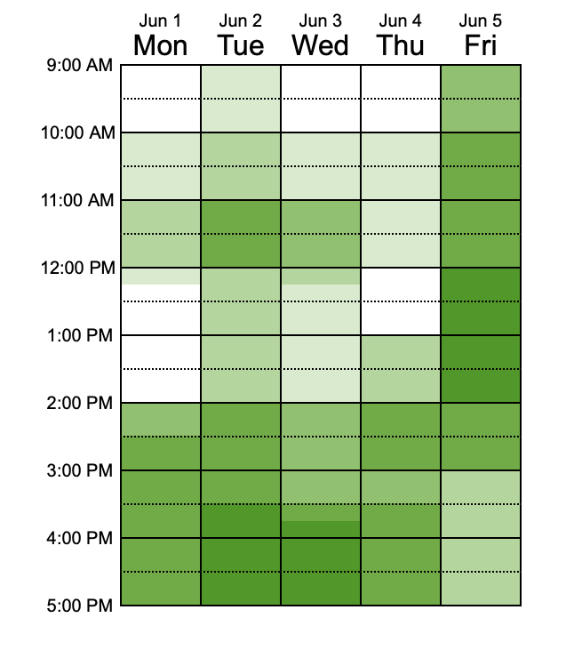
      - Can we get a graphic out for free energy drinks / coffee in the arbor at that date and time for students who sign up on the CoC website and view open AS positions (application encouraged but not required) → Charge up your resume (???) any other titles
      - I’m fully gone friday, who can take point on this? Should just be transporting boxes from AS main to the arbor

Shuyi Sum - External Chair
    - QOTW: China trip !!
    - I like top left or middle right for the logo
    - Set up 2 interviews for this week:
      - Tommy Theam (t_theam@ucsb.edu)
CoC O&R Careers Coordinator
Friday 5/29 1:30-2:00PM
Oliver, Layla
      - Desiree Avelar (dvgarrido-avelar@ucsb.edu)
CoC O&R DEI Coordinator
Friday 5/29 4:30-5:00PM
Lily, Savanah

Oliver Ramirez Carrera - Vice Chair
    - QOTW: Definitely the most excited for my internship!
    - I like the top left logo the most
    - Created Internal Liaison resources, linked in Drive
    - RVSP’d for A.S. Awards Banquet
    - Sent out email to Controller applicants; also created a Google Form for their positions, emailed the spreadsheet to Lauren
    - Got in touch w/ Kristin for passdown reports
    - Met with advisors to discuss CoC’s role for next year. Got valuable input from advisors on what they believe we have been doing well, and not. Super helpful!
    - Filled out BCU Appointment Form
    - Scheduled email to be sent out to Tommy Theam for tomorrow morning
    - Added Queer Commission’s positions to the CoC website
    - Met w/ Oscar and got the email situated sorted for
      - COC Outreach and Recruitment DEI Coordinator
      - Not sure if I should list the password on the minutes, but.. Here it is: coznet-7gefci-Govxuz
    - Tasks:
      - Work on compiling list of website issues for Alex

VACANT - Internal Liaison

Layla Hakim - Outreach and Recruitment Careers Coordinator
    - QOTW: beaching and tanning!
    - Sent out department emails for CoC, LHP, Office of the Controller, TQCOMM
      - Responses from history and sociology so far
    - Will do interview for tommy on friday
    - Got the email about the passwords and still need to respond but will hopefully do the zoom with them this/next week
    - Lowkey super busy the next few weeks + out of town next weekend, so I’m not sure if I can put together a full event, but I likely can table at some point (out of town the 5th though)

Mira Ikladious - Outreach and Recruitment Media Coordinator-
  - QOTW: I work my medical assistant job 8-5pm everyday so I'm excited to learn a ton!
  - Will post the COC post and Office of the Controller TONIGHT
  - Reached out to OOTC and they said they wanted to do the interviews I think but wanted us to advertise.
  - Just signed into microix today with Oscar, will approve Lily’s req tonight.
  - Sorry for any lateness, I had 3 midterms this week!
  - Make post for COC event!!!!

VACANT - Outreach and Recruitment DEI Coordinator

Savanah Lizet Aldaba - Outreach and Recruitment On-Campus Coordinator
    - QOTW- Trips to Seattle
    - Zoom meeting tomorrow with Oscar to set up new O&R email
    - Interviewing Desiree next week
      - I can also table at the arbor on friday!

Archish Prakhya - Pearman

Adam Orenstein - Commissioner of Community and Climate

C. Action Items

- ACCEPTANCE of AGENDA/CHANGES to AGENDA

- CONSENT ITEMS

- Approval of our Action Summary/Minutes from:

- ACTION ITEMS

F-1. Old Business:

F-2 New Business:

- DISCUSSION ITEMS

- Discussion Topic

- REMARKS

- ADJOURNMENT

MOTION/SECOND: Mira/Savanah
Motion Language: Motion to adjourn this meeting at 5:30pm.
ACTION: CONSENT

